Private Sector-Led Reform:
Advocating for a Better Business Environment in Egypt

by

Hisham El Attal, ABA Board Member;
Marwan El Sammak, ABA Board Member and Secretary General; and
Maha Hussein, Investment Climate Associate Operations Officer

Presented at the Public-Private Dialogue 2010 Workshop
(Vienna, June 1-3 2010)

1- Background and Context

During the past few years, the Government of Egypt has adopted a reform approach, where laws and regulations were amended, procedures streamlined, and internal and foreign trade facilitated. This resulted in the improvement of Egypt's Doing Business ranking out of 181 countries, from 165 in 2007 to 106 in 2010. Despite the various reform initiatives Egypt has undertaken, economic development would still benefit from an integrated reform approach, where the government and the private sector work for a common goal. The core element for sustainable economic development is for the private sector to identify the opportunities for reform through cooperation and coordination with the relevant decision makers. The private sector can support and measure government reform efforts to simplify procedures, eliminate obstacles, and facilitate the doing business process for investors.

In November 2005, IFC started the business start-up simplification project, working with the General Authority for Investment and Free Zone (GAFI) and the Governorate of Alexandria. Based on a detailed review of all administrative procedures involved in registering a business in Alexandria, the project aimed at streamlining and reducing all procedures needed to start a business in the Alexandria governorate. In order to support these ongoing reform efforts, IFC signed a collaboration agreement with the Alexandria Business Association (ABA) to become the private sector partner, actively involved in the project and to ensure that all improvements in the business environment truly serve the private sector as the intended beneficiary of these reform.

ABA was established in 1988 as a nonprofit nongovernmental organization. It is one of the strongest business associations in Alexandria and one of the most renowned in Egypt. Collaboration with the ABA focused on strengthening their advocacy capacities, to empower them to measure the impact of the government reforms on their members. The main result of the cooperation between ABA and IFC during phase I of the project (June 2007 – June 2009) was to establish a private sector observatory within ABA to monitor the implementation of reforms initiated by the business registration simplification program, using the Islah Reform Index. The Islah Reform Index monitors reforms reflecting the attractiveness and cost of doing business in Egypt. Impact of government reforms is measured using regular annual surveys. The first issue of the index, launched during phase I of the project, was a pilot, limited to Alexandria.

2- Partnership, Structure and Processes

Phase II (January 2010 – April 2011) of the project will continue to build on the results of the initial phase, as well as introduce new interventions to be adopted and owned by ABA. Within ABA, an Advocacy Unit was established as a vehicle to advocate for reform and to improve the regulatory framework of doing business in Egypt. The unit is expected to provide a private sector view on the business climate in Egypt as well as raise public awareness on the need for private sector contribution to reform. The Advocacy Unit mandate is to work with the government, to set the reform agenda and become a platform to annually launch the Islah Reform Index. The Advocacy Unit will work to resolve priority issues in the reform agenda, using the annual results of Islah Reform Index. Accordingly, ABA will house a sustainable mechanism that will continue to advocate for reform beyond the duration of the project.

The Advocacy unit was established to comprise five ABA board members and two permanent staff members. The unit’s mandate and responsibilities were identified and an organizational structure designed, complete with job descriptions and hiring timelines. By May 2008, the unit was operational and was instrumental in the success of the project. In May 2009, the board members were discussing the need to hire new permanent staff to support the unit. In May 2010, 3 new permanent hires joined the Advocacy Unit.

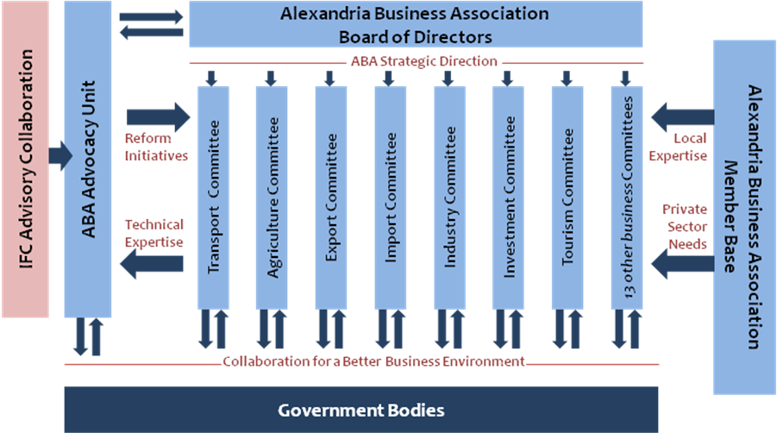
3- Results of Phase I

During phase I of the project, the pilot survey was conducted with a sample of 100 Alexandria businesses (33% of ABA’s member base. This was a representative sample size. Eleven policy areas were identified and the indicators to measure each policy area were set. The survey was designed in English and later translated into Arabic for dessimintaion. Based on the data collected, analyzed and aggregated from the survey, the Reform Index was developed. The branding of the reform index and communication templates were created. The Index’s name (Islah) as well as the logo, colours and slogan were designed to reflect the theme of reform and ABA’s identity as an Egyptian business association.
The Islah Reform Index report was developed, in coordination with IFC and ABA. The report included the findings of the survey, based on data from ABA’s member organizations. The report covered the 11 policy areas, through the assessment of qualitative and quantitative aspects of the business climate such as transparency, simplicity of procedures and quality of service within government agencies.

The launch of Islah Reform Index took place on May 4th 2009. The event was attended by the Minister of Investment, Minister of Trade and Industry and the Minister of Administrative Development; where each gave a key note speech on the importance of including the private sector in the reform agenda. Delegates from the Swiss Embassy in Cairo, the General Authority for Investment and Free Zones and IFC also presented at the event, endorsing the role of the private sector. The event was attended by approximately 160 private and public sector representatives. The event received high media coverage, where interviews were organized with the keynote speakers. During the event, ABA signed a memorandum of understating with the Ministry of Trade and Industry and IFC, to develop and launch the first micro enterprise reform index, expected to launch in 2011. ABA also signed cooperation agreements with the Egyptian Businessmen Association and the Confederation of Egyptian European Business Associations, to widen the scope of Islah, to become a national business climate reform index, with the second issue expected to launch towards the end of 2010.

4- Expected Results of Phase II

The overall objective of the collaboration between IFC and ABA is to improve private sector growth. By the end of phase II of the project, ABA will function as a sustainable mechanism to advocate for private sector reform in Egypt, ensuring the sustainability of efforts after the reform completion. The project will enhance the existing diagnostic tools, as well as work to develop new tools to help identify regulatory constraints for enterprises, as well as increasing transparency and governance.

The project will work on eliminating or improving 28 recommended procedures, policies or practices, related to Business registration, Operating licenses, Industrial licenses or Construction permits. Three entities will implement the recommended changes namely General Authority for Free Trade and Investment (GAFI) – Ministry of Investment, Industrial Development Authority (IDA) – Ministry of Industry and Trade and Ministry of Housing, Utilities and Urban Development. The above areas are potential areas of engagement that may change according to private sector needs and Islah Index findings.

Biographies of Authors:

Hisham El Attal is the president of Egyptian Traders Company, trading in commodities, agricultural products and raw materials. He is also the vice chairman of El Ahram for Development, a Sudan-based company, trading in commodities, agricultural products and fast moving consumer goods as well as Food Aid. Hisham graduated from Alexandria University in 1987, with a B.Sc. in Production Engineering, and then he continued to pursue post graduate studies in the field of Artificial Intelligence. In 1988 Hisham joined Schlumberger where he spent five years in both training and operations with the company in the United Kingdom, India, Singapore, the United Arab Emirates and Egypt. Hisham has an interest in creating a better business environment. Primarily, he is a board member of the Alexandria Business Association and a member of the Advocacy Unit, collaborating with IFC. He is an active member of the Agriculture Modernization Council headed by the Minister of Agriculture; a member of the steering committee of the Egyptian – Japanese University headed by the Minister of High Education; a member of the Agriculture Export Council & Chair of Rice Committee appointed by the Minister of Trade and Industry; as well as many other appointments.

Marwan El Sammak is the General Manager of Medlevant Shipping Company, Worms Group Company and the agent of Hapag Lloyd Container Line. He has 19 years of experience in management activities with an engineering background, management, business development and business planning. Born in Alexandria Egypt, he graduated from the Faculty of Engineering Alexandria University, with a Bachelor in Marine Engineering & Ship Building. Marwan is a visionary intellectual and a socially responsible citizen with a strong interest in global issues reflected on his valuable contribution to the Egyptian community, to leverage standards of the community, via his active participation, spearheaded a number of initiatives, having a lot of accomplishments in numerous Boards, Councils and Associations such as being; An active Board Member of several organizations including Alexandria Business Association as Secretary General, Alexandria Chamber of Shipping as President of the Training Development Committee. Besides, he is an Active member of the Egyptian Junior Business Association (EJB), and many other associations and chambers that promote Economical, Social and Cultural development. In April 2010, Marwan was nominated as one of main shortlist candidates for acting as Rapporteur in the "Logistics Export Council" based on a Ministerial decree of the Minister of Trade & Industry.

Maha Hussein is an investment climate associate operations officer, working on PPD projects in the MENA region. Prior to joining the investment climate business line in 2008, Maha worked with the MENA Monitoring and Evaluation team, as well as the Corporate Advice business line, focusing on supporting Business Membership Organizations. Prior to joining IFC in 2006, Maha had 12 years of experience in strategic management, business development and human resource development. Maha holds a BA in Economics from the American University in Cairo, an MBA from the Maastricht School of Management and an MSc in the Design and Management of Information Systems from the London School of Economics and Political Science.

